Key Metrics:-

Metrics show quantitative information about visitor activity, such as Views, Click-Throughs, Reloads, Average Time spent, Units, Orders, and Revenue.

| **Metric Name** | **Definition** | **Documentation Link** |
| --- | --- | --- |
| Full Metric List | Definition of all metrics in Adobe Analytics. | <https://marketing.adobe.com/resources/help/en_US/reference/metrics.html> |
| Unique Visitors | The number of unduplicated visitors to the website over the course of a specified time period. | <https://marketing.adobe.com/resources/help/en_US/reference/metrics_unique_visitors.html> |
| Visits | A sequence of page views in a sitting. The visit begins when a person first views a page on the site and ends after 30 minutes of inactivity. | <https://marketing.adobe.com/resources/help/en_US/reference/metrics_visit.html> |
| Page Views | A page view occurs when a visitor views a page on your web site. | <https://marketing.adobe.com/resources/help/en_US/reference/metrics_page_view.html> |
| Instances | The number of times a variable was defined. Each time Adobe Analytics sees a value within a variable, instances are incremented by one in that respective report. | <https://marketing.adobe.com/resources/help/en_US/reference/metrics_instance.html> |
| Calculated Metrics | Custom metrics that you can create from existing metrics. For example, if you have the revenue and the number of visits, you can create a custom metric for average revenue per visit or revenue divided by visits (revenue/visits). | <https://marketing.adobe.com/resources/help/en_US/analytics/calcmetrics/> |

1.Full Metric List:-

Metrics and associated data are displayed in the columns of reports. Broad categories of metrics include:

**Traffic metrics**: These show data about the volume of visitors.

**Conversion metrics**: These show data about success events, such as purchases, downloads, or any other action that you want users to take on your website.

[**Calculated**](https://marketing.adobe.com/resources/help/en_US/analytics/calcmetrics/index.html)**metrics**: These are metrics you create by combining metrics.

[**Video**](http://marketing.adobe.com/resources/help/en_US/sc/appmeasurement/video/index.html)**metrics**: Marketing reports provide support for tracking a number of video metrics, including total views, time spent, and completion rates.

[**Social**](http://marketing.adobe.com/resources/help/en_US/social/index.html?f=c_Getting_Started_with_Social)**metrics**: These help you measure your brand's presence on the social web. Social metrics work with Analytics standard metrics. By combining these with calculated metrics, you can view a report that shows how often a product is mentioned, gauge product sentiment, and see how Social metrics correlate with Analytics key performance indicators.

How you can **hide metrics** in some user interfaces:-

* [**Metrics Quick Reference**](https://marketing.adobe.com/resources/help/en_US/reference/metrics_overview.html)  
  Lists the standard metrics in Adobe Analytics.
* [**Metric Calculations**](https://marketing.adobe.com/resources/help/en_US/reference/metrics_calculations.html)  
  Metrics are calculated using *standard*, *participation*, *recent*, and *linear* allocation methods. Each method calculates values differently based on formulas.
* [**Average Page Depth**](https://marketing.adobe.com/resources/help/en_US/reference/metrics_av_page_depth.html)  
  Displays on average how far within a visit each value was fired. This metric is valuable in determining how far within a visit your audience reaches a given page or prop value. Average Page Depth is available on any variable with pathing enabled.
* [**Average Time Spent**](https://marketing.adobe.com/resources/help/en_US/reference/metrics_av_time_spent.html)
* [**Bounces**](https://marketing.adobe.com/resources/help/en_US/reference/metrics_bounces.html)  
  A visit that consists of a single server call. For example, a single page visit is a bounce if a visitor does not interact with the page in a way that sends data to Adobe, such as clicking a link or a video start. If more than a single hit is received in a visit, a Bounce is not counted.
* [**Bounce Rate**](https://marketing.adobe.com/resources/help/en_US/reference/metrics_bounce_rate.html)  
  Shows the percentage of visits that contain a single hit.
* [**Calculated Metrics**](https://marketing.adobe.com/resources/help/en_US/reference/calculated_metric.html)  
  Calculated metrics enable you to combine metrics to create mathematical operations that are used as new metrics. These metrics can be created for a report to which you add metrics. Administrators can create calculated metrics for all users of a report suite.
* [**Campaign-Specific Metrics**](https://marketing.adobe.com/resources/help/en_US/reference/campaign-specific_metrics.html)  
  Campaign-specific metrics are fixed numeric values associated with a campaign, such as the hard cost for a campaign.
* [**Cart Additions**](https://marketing.adobe.com/resources/help/en_US/reference/metrics_cart_additions.html)  
  The number of times an item was added to a shopping cart. This value comes from the scAdd event.
* [**Cart Open**](https://marketing.adobe.com/resources/help/en_US/reference/metrics_cart_open.html)  
  The number of times a customer opened a shopping cart by adding the first item. Occurs the first time an item is added to the shopping cart. This value comes from the scOpen event.
* [**Cart Removals**](https://marketing.adobe.com/resources/help/en_US/reference/metrics_cart_removals.html)  
  Number of times an item was removed from a shopping cart. This value comes from the scRemove event.
* [**Cart Views**](https://marketing.adobe.com/resources/help/en_US/reference/metrics_cart_views.html)  
  Event in which the contents of the shopping cart are viewed by the customer.
* [**Checkouts**](https://marketing.adobe.com/resources/help/en_US/reference/metrics_checkouts.html)  
  An event that occurs when customers arrive at the checkout stage of a purchase. The checkout stage usually occurs just before a purchase is finalized, and usually involves the customer entering personal information (such as their shipping and billing information). You have control over the events on your site that qualify as checkouts. This value comes from the scCheckout event.
* [**Click-throughs**](https://marketing.adobe.com/resources/help/en_US/reference/metrics_click-throughs.html)  
  Click-throughs represent a) campaign instances, and b) marketing channel instances.
* [**Custom Metrics**](https://marketing.adobe.com/resources/help/en_US/reference/metrics_custom.html)  
  Custom metrics let you track additional success metrics on your site.
* [**Daily Unique Visitors**](https://marketing.adobe.com/resources/help/en_US/reference/metrics_daily_unique_visitors.html)  
  The number of unduplicated (counted only once) visitors to your website over the course of a single day. The visit for the Daily Unique Visitor ends at midnight for the time zone selected in the report suite.
* [**Entries**](https://marketing.adobe.com/resources/help/en_US/reference/metrics_entries.html)  
  *Entries* represents the number of times a given value is captured as the first value in a visit. *Entries* can occur only once per visit. However, it is not necessarily the first hit if the variable is not defined.
* [**Exits**](https://marketing.adobe.com/resources/help/en_US/reference/metrics_exits.html)  
  The number of times a given value is captured as the last value in a visit. *Exits* can occur only once per visit.
* [**Instances**](https://marketing.adobe.com/resources/help/en_US/reference/metrics_instance.html)  
  The number of times that a value was set for a variable.
* [**Mobile Views**](https://marketing.adobe.com/resources/help/en_US/reference/metrics_mobile_views.html)  
  The number of times a page is viewed or a dimension is set when accessed via a mobile device. Ad hoc analysis only.
* [**Monthly Unique Visitors**](https://marketing.adobe.com/resources/help/en_US/reference/metrics_monthly_unique_visitors.html)  
  The number of unduplicated (counted only once) visitors to your website over the course of a single month.
* [**New Engagements**](https://marketing.adobe.com/resources/help/en_US/reference/metrics_new_engagements.html)  
  New Engagements is a Marketing Channel reporting metric that indicates a first-touch channel has been newly set for a visitor. This can occur the first time a visitor visits the site or when the visitor returns to the site after a previous first-touch channel has expired. (Marketing Channel expiration can be set as desired by the report suite by adjusting the Visitor Engagement Expiration in Admin Tools. If not set for the report suite, the expiration defaults to 30 days since the visitor's last visit or hit of the visitor.)
* [**Occurrences**](https://marketing.adobe.com/resources/help/en_US/reference/metrics_occurrences.html)  
  The number of times a specific value is captured, plus the number of page views for which the given value persisted. In other words, Occurrences are sum of page views and page events. Occurrences are available in Analysis Workspace and in Ad Hoc Analysis.
* [**Orders**](https://marketing.adobe.com/resources/help/en_US/reference/metrics_orders.html)  
  The number of orders made on your website during the selected time period. You can break down individual time periods by other metrics to show the items (such as products or campaigns) that contributed to the most orders during that time frame.
* [**Page Depth**](https://marketing.adobe.com/resources/help/en_US/reference/metrics_page_depth.html)  
  The average number of clicks it takes users to get to a certain page in the website.
* [**Page Events**](https://marketing.adobe.com/resources/help/en_US/reference/metrics_page_event.html)  
  Page events consist of image request data from non-standard image requests. Sources of non-standard image requests are download links, exit links, and custom link tracking.
* [**Page View**](https://marketing.adobe.com/resources/help/en_US/reference/metrics_page_view.html)  
  A Page View is counted for each server call that is sent. This metric represents total instances of Page View. TrackLink calls are not counted as page views and do not increment the Page Views metric.
* [**Participation**](https://marketing.adobe.com/resources/help/en_US/reference/metrics_participation.html)  
  Participation metrics assign full credit from success events to all values of an eVar that were passed during a visit. Participation metrics are useful to determine which pages, campaigns, or other custom variable values are contributing most to the success of your site. Participation is visit based. All eVar values in a visit prior to and including the hit when an event occurs receive participation credit regardless of the expiration setting.
* [**Path Views**](https://marketing.adobe.com/resources/help/en_US/reference/metrics_path_views.html)  
  The Path Views metric is based on pathing data, which is tracked for all users who accept persistent cookies.
* [**People**](https://marketing.adobe.com/resources/help/en_US/reference/metric_people.html)  
  The People metric is an Adobe Analytics reporting metric that helps you attribute devices to people.
* [**Product Views**](https://marketing.adobe.com/resources/help/en_US/reference/metrics_prod_views.html)  
  Instance of the Product View being set. Occurs when the product detail page is viewed. This value comes from the prodView event.)
* [**Quarterly Unique Visitors**](https://marketing.adobe.com/resources/help/en_US/reference/metrics_quarterly_unique_visitors.html)
* [**Reloads**](https://marketing.adobe.com/resources/help/en_US/reference/metrics_reloads.html)  
  Counted when the same page name is loaded twice in-a-row. This typically indicates that the page was refreshed.
* [**Revenue**](https://marketing.adobe.com/resources/help/en_US/reference/metrics_revenue.html)  
  Revenue is captured on the purchase event, and is defined as the total dollar amount for the sum of the order for each product. This value comes from the purchase event.
* [**Searches**](https://marketing.adobe.com/resources/help/en_US/reference/metrics_searches.html)  
  The recommended default metric for search engines and keywords. This metric represents instances of a click-through, and shows the page that is associated with a specific engine or keyword. Searches metric data can be reported retroactively to the beginning of the data set.
* [**Single Access**](https://marketing.adobe.com/resources/help/en_US/reference/metrics_single_access.html)  
  Single Access is defined by the number of visits to your site that contained a single unique Page Name value. If a user comes to your site and clicks a tracked link, triggers an event (such as a video view), or reloads the page, the visit is still considered a Single Accessvisit. As long as value for the pageName variable does not change, any number of requests can be sent and the visit is still considered a Single Access.
* [**Time Spent**](https://marketing.adobe.com/resources/help/en_US/reference/metrics_time_spent.html)  
  Adobe Analytics offers various Time Spent metrics and dimensions. Find out what they are and how they are calculated.
* [**Total**](https://marketing.adobe.com/resources/help/en_US/reference/metrics_total.html)  
  The value of all report line items for a reported period. If a filter is currently selected, the total might represent the filtered total instead of the report suite total. If no filter is selected total represents the report suite total.
* [**Unique Visitors**](https://marketing.adobe.com/resources/help/en_US/reference/metrics_unique_visitors.html)  
  In version 14, a unique visitor refers to a visitor who visits a site for the first time within a specified time period. For example, the unique visitor can visit a site ten times in a week, but if the time period is week, a single unique visitor is counted only once for that week. After that week is ended, that unique visitor can be counted again for a different time period.
* [**Units**](https://marketing.adobe.com/resources/help/en_US/reference/metrics_units.html)  
  The total units that were ordered for the selected time period. Because you have many units purchased per order, Units is a vital metric that reveals general inventory movement.
* [**Visit**](https://marketing.adobe.com/resources/help/en_US/reference/metrics_visit.html)  
  A sequence of page views in a sitting. The visits metric is commonly used in reports that display the number of user sessions within the selected time period.
* [**Visitors**](https://marketing.adobe.com/resources/help/en_US/reference/visitors.html)  
  The number of unique visitors to your site for a selected hour, day, week, month, quarter, or year.
* [**Visitors with Experience Cloud ID**](https://marketing.adobe.com/resources/help/en_US/reference/metric_visitors_mcid.html)  
  Available in Analysis Workspace and the Segment Builder.
* [**Visitor Participation - Ad Hoc Analysis**](https://marketing.adobe.com/resources/help/en_US/reference/metrics_visitor_participation.html)  
  Visitor Participation is a metric series that lets you view participation across visitor sessions in marketing channels, campaigns, revenue, and so on. For example, purchase and revenue credit can be attributed back to other marketing touch-points that occurred before the visit in which the order took place. Ad hoc analysis provides visitor participation across visits.
* [**Weekly Unique Visitors**](https://marketing.adobe.com/resources/help/en_US/reference/metrics_weekly_unique_visitors.html)  
  A unique visitor refers to an individual who has visited a site the first time within a certain time period. For example, the unique visitor could have visited a site 10 times in a week, but if the time period specifies unique visitors for that week, a single unique visitor will only be counted once for that week. Once that week is over, that unique visitor can be counted again for a new specified time period.

# 2. Unique Visitors:-

A unique visitor refers to a visitor who visits a site for the first time within a specified time period.

**Differences between version 14 and 15**

version 14 does not remove duplicate Visits and Unique Visitors metrics from classifications-based reports. For example, if two video clips shared the same classification, a single visitor that viewed both clips generated two Visits and Unique Visitors in the classification-based report.

Version 15 removes duplicate Visits and Unique Visitors from the classification-based report. This is a more accurate measure of Visits andVisitors, but typically results in a decrease in your Visits and Unique Visitors metrics for classification-based reports, when compared to data collected prior to upgrade.

| **Uses** | **Description** |
| --- | --- |
| Traffic | A visitor is a person that comes to your website. Does not require a persistent cookie. |
| Conversion | A visitor is a person that comes to your website. Is counted when a conversion-related event or action occurs. |
| Ad Hoc Analysis | A visitor is a person that comes to your website. Does not require a persistent cookie. |

# 3. Visit

A sequence of page views in a sitting. The visits metric is commonly used in reports that display the number of user sessions within the selected time period.

The visit metric is always associated with a time period, so you know whether to count a new visit if the same visitor returns to your site. A session starts when the user first arrives on your site, and ends under one of the following scenarios:

* **30 minutes of inactivity:** Almost all sessions end in this manner. If more than 30 minutes has lapsed between image requests, a new visit begins.
* **12 hours of consistent activity:** If a user fires images requests without a 30+ minute gap for 12 hours, a new visit automatically starts.
* **2500 hits:** If a user generates a large number of hits without starting a new session, a new visit is counted after 2500 image requests.
* **100 hits in 100 seconds**: If a visit consists of more than 100 hits that occur in fewer than 100 seconds, the visit automatically ends. This behavior typically indicates bot activity, and this limitation is enforced to prevent these processing-intensive visits from increasing latency and increasing the time it takes to generate reports.

The following scenarios do not start a new visit:

* The user closing the tab, reopening it, and navigating back to your site within 30 minutes. The user can also close his browser or reboot the computer and still be counted as a single visit (given the visitor returns to your site within the 30-minute time period).
* Users browsing your site in multiple tabs. Though multi-tabbed browsing does not increment visits or visitors, using a separate browser does. This is because the different tabs reference the same cookies, while separate browsers do not.

# 4.Page View:-

A Page View is counted for each server call that is sent. This metric represents total instances of Page View. TrackLink calls are not counted as page views and do not increment the Page Views metric.

A useful way to use the Page View metric is to run a **Paths** > **Pages** > **Entry Pages** report, sort by it, and see which entry pages drive the most page views.

| **Uses** | **Description** |
| --- | --- |
| Traffic | A page view occurs when a visitor accesses a page on your website. |
| Conversion | A page view occurs when a visitor accesses a page on your website. |
| Ad Hoc Analysis | A page view occurs when a visitor accesses a page on your website. |

# 5. Instances

The number of times that a value was set for a variable.

Instances are counted for all hit types, but are not counted when a value is recorded for a variable on a subsequent hit due to persistence.

For example, if a user arrives on your site via example.com, the first image request on your site contains the referrer of example.com. When this value is set, one Instance is attributed to example.com even though this referrer is recorded for all pages viewed during that visit.

6. Calculated Metrics:-

Calculated and Advanced Calculated (or Derived) Metrics are custom metrics that you can create from existing metrics.

Our Calculated Metrics tools offer a highly flexible way of building, managing and curating metrics. They allow you as marketers, product managers and analysts to ask questions of the data without having to change your Adobe Analytics implementation. The custom metrics available in each Analytics package are:

* Adobe Analytics Foundation: Calculated
* [Adobe Analytics Select](http://www.adobe.com/data-analytics-cloud/analytics/select.html): Calculated + Advanced Calculated
* [Adobe Analytics Prime](http://www.adobe.com/data-analytics-cloud/analytics/prime.html): Calculated + Advanced Calculated
* [Adobe Analytics Ultimate](http://www.adobe.com/data-analytics-cloud/analytics/ultimate.html): Calculated + Advanced Calculated

| **Builder Options** | **Calculated Metrics** | **Advanced Calculated (Derived) Metrics** |
| --- | --- | --- |
| [Format types (decimal, time, percent, currency)](https://marketing.adobe.com/resources/help/en_US/analytics/calcmetrics/cm_build_metrics.html#concept_5EC82A91EB9C44FC870326C85F9D0B18) | Yes | Yes |
| [Allocation changes (default, linear, participation, etc.)](https://marketing.adobe.com/resources/help/en_US/analytics/calcmetrics/m_metric_type_alloc.html#concept_B7A1FCFEFA9D4C4883208ACE8C9C8E5E) | Yes | Yes |
| [Metric types (standard, total)](https://marketing.adobe.com/resources/help/en_US/analytics/calcmetrics/m_metric_type_alloc.html#concept_B7A1FCFEFA9D4C4883208ACE8C9C8E5E) | Yes | Yes |
| Basic operators (add, subtract, multiply, divide) | Yes | Yes |
| [Applying segments](https://marketing.adobe.com/resources/help/en_US/analytics/calcmetrics/metrics_with_segments.html#concept_21C77BD86E7E45E79AF030D8ED54DB3E) | No | Yes |
| [Basic functions (count, abs value, mean, etc)](https://marketing.adobe.com/resources/help/en_US/analytics/calcmetrics/cm_functions.html#concept_E3022D5EEEE145B69A23438BAF7016B2) | No | Yes |
| [Advanced functions (regression, if/then, t-score, etc)](https://marketing.adobe.com/resources/help/en_US/analytics/calcmetrics/cm_adv_functions.html#concept_A5FB9127D70F4E1AA02D1ACBF4F54174) | No | Yes |

* Processing Rules and Implementation:-
  + - Processing rules simplify data collection and manage content as it is sent to reports.
    - Processing rules help simplify interaction with IT groups and Web developers by providing an interface to:
* Set an event on the product overview page
* Populate campaign with a query string parameter
* Concatenate category and page name in a prop for easier reporting
* Copy an eVar into a prop to see paths
* Clean up misspelled site sections
* Pull internal search terms or a campaign ID from the query string into an eVar

For details about processing rules:-

## **Get Authorized to Use Processing Rules**

Now, administrators have rights to use processing rules **by default**. The exam is no longer necessary. Administrators can also grant these rights to non-administrators through the Admin Tools interface. Here's how:

1. If you have not already done so, [create a group](https://marketing.adobe.com/resources/help/en_US/reference/define_user_group.html#concept_DBBCB8275D554B02B4B4E1168BA69A05) that includes only those non-admins that should have authorization to use processing rules.
2. [Add the non-administrator/s to that group](https://marketing.adobe.com/resources/help/en_US/reference/t_add_user_to_group.html#task_0EE07E66139C4477B8505F3EB4BB05B8).
3. Then go to **Analytics** > **Admin** > **User Management** > **Groups** > **[group name]** > **Edit** > **Report Access** > **Report Suite Tools** > **Customize** > **Report Suite Management**.
4. Check the box next to Processing Rules and click **OK**.

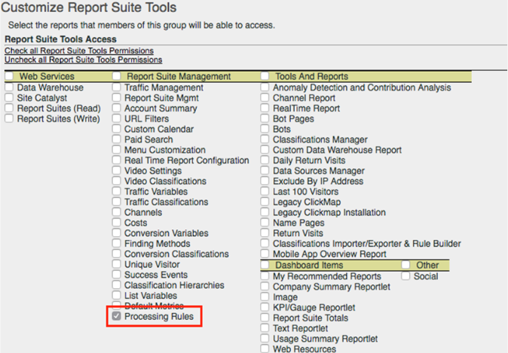

## **Use Context Data to Simplify Data Collection**

Context data variables are a new type of variable that are available only to processing rules. To use context data variables, key/value data pairs are sent in by your implementation, and processing rules are used to capture these values in standard Analytics variables. This frees programmers from understanding exactly which prop and/or eVar should contain which value.

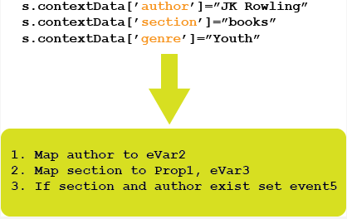

## **Use Processing Rules to Transform Hit Data and Trigger Events**

Processing rules can monitor incoming values to transform common typos and set events based on reported data. Props can be copied to eVars. Values can be concatenated for reports, and events can be set.

# Configure Processing Rules:

* [**How Processing Rules Work**](https://marketing.adobe.com/resources/help/en_US/reference/processing_rules_about.html)  
  Processing rules let you make changes to data based on defined conditions. When attributes or values match defined conditions, values can be set and deleted, and events can be set.
* [**Processing Order**](https://marketing.adobe.com/resources/help/en_US/reference/processing_rule_order.html)  
  To effectively use processing rules it is essential to understand when they are applied during data collection.
* [**Create processing rules**](https://marketing.adobe.com/resources/help/en_US/reference/t_processing_rules.html)  
  Processing rules are set on report suites.
* [**View active processing rules**](https://marketing.adobe.com/resources/help/en_US/reference/t_processing_rules_view.html)  
  Active processing rules are viewed in admin.
* [**View processing rule history**](https://marketing.adobe.com/resources/help/en_US/reference/t_processing_rule_view_history.html)  
  Changes to processing rules can be viewed in History.
* [**Restore processing rules**](https://marketing.adobe.com/resources/help/en_US/reference/t_processing_rules_restore.html)  
  Processing rules can be restored from history.
* [**Copy processing rules to another report suite**](https://marketing.adobe.com/resources/help/en_US/reference/t_processing_rules_copy_to_rs.html)  
  Steps that describe how to copy processing rules from one report suite and replace or append these rules to another report suite.

| **Concept** | **Details** |
| --- | --- |
| Rules apply to a single report suite. | [Copy processing rules to another report suite](https://marketing.adobe.com/resources/help/en_US/reference/t_processing_rules_copy_to_rs.html#task_6E4B82FCA687409B88F17EAFC353755D) |
| Processing rules are applied in the order listed. | If an action changes a value, subsequent conditions use the new value. |
| Processing rules are applied immediately to the report suite after they are saved. | Changes from processing rules should be visible in your report suite within minutes of saving. When testing processing rules, we recommend configuring [Real-Time](https://marketing.adobe.com/resources/help/en_US/reference/realtime.html#concept_6E8756BDDAE843F88B6563C09C48B0B6) in your test report suite so you can quickly see the results of a processing rule. |
| Processing rules are the only way to access to context data variables. | [Copy a Context Data Variable to an eVar](https://marketing.adobe.com/resources/help/en_US/reference/processing_rules_copy_context_data.html#concept_43AA4980A2D847D6A3BEC50BCC0780E7) |
| Processing rules are applied before VISTA rules and Marketing Channel rules. | [Processing Order](https://marketing.adobe.com/resources/help/en_US/reference/processing_rule_order.html#concept_8A6BBEA7F50C40C8A8D8755D4F579B1E) |
| Hits cannot be excluded. | You can use VISTA rules to exclude hits. |
| The product string, referrer, and user agent cannot be changed. | Referrer and user agent are read-only. The product string is not available. |
| Mobile device attributes and classifications are not available. | The mobile device lookup occurs before processing rules, but attributes are not available in processing rules. |
| Query string parameters cannot be read beyond the first 255 characters of a URL if you are running JavaScript AppMeasurement H.25.2 or earlier. JavaScript AppMeasurement H.25.3 (released January 2013) and later provide the full URL including all query string parameters to processing rules. | Upgrade to H.25.3 or later, or read query string parameters from long URLs client-side and store values in Context Data variables. |
| Query string values must be encoded in Unicode or UTF-8 to be read by processing rules. | This might affect multibyte characters that are passed using query strings. |
| You are limited to 150 rules with 30 conditions each for each report suite. | Processing rule limits are per report suite, not per company. |
| Processing rules must be set up to retrieve context data variables before data is sent. | Processing rules are applied as server calls are sent. Values stored in context data variables are discarded if they are not copied using processing rules. |
| Value comparisons in the UI are case insensitive. | [Cleaning up Values in a Report](https://marketing.adobe.com/resources/help/en_US/reference/clean_up_values_in_a_report.html#concept_958E924BCCBB4BBA91CE91C977FE5151). |
| Context data variable names can contain only alphanumeric characters, underscores and dots. Any additional characters are stripped out. | For example, The context data variable login\_page-homeautomatically becomes login\_pagehome. All data sent to thelogin\_page-home variable is allocated under login\_pagehome.  Context data variables that contain unsupported characters cannot be added in the Processing Rules interface. |
| Caret (^) is a special character in the processing rules system. | To match a single caret character, use two caret characters (^^). |

## **Processing Rule Conditions**

Conditions check page variables for a matching value or if a value is present. Multiple conditions can be added and you can select if all conditions must be matched.

You can create a rule with no conditions to always execute defined actions.

Variables are not automatically checked for values before actions occur. For example, Prop1 contains a value of "something", and eVar1 is empty. If you set Prop1 to equal eVar1 both values will be empty. If you need to avoid this add a condition to check for the presence of a value.

# Create New Rule

Steps that describe how to create rules in Dynamic Tag Management.

1. [Create Web Property](https://marketing.adobe.com/resources/help/en_US/sc/implement/t_create-web-property.html#task_960467FBB7A54499AC228CB3AA3C4123), if you haven't done so already.
2. In the web property, click the **Rules** tab.
3. Select the type of rule you wish to create from the left navigation pane, such as Event Based Rules or Page Load Rules.
4. Click **Create New Rule**.
5. Name the rule and select a category, if you wish.
6. Next, set up the condition(s) for the rule. The setup differs depending on the type of rule you are implementing.

| **Type of Rule** | **Refer to this Topic** |
| --- | --- |
| **Event-based rule** | [Create Conditions for Event-Based Rules](https://marketing.adobe.com/resources/help/en_US/sc/implement/t_rules-event-conditions.html#task_A122DE72110F4579A91F9D96D92D39FC) |
| **Page Load rule** | [Create Conditions for Page-Load Rules](https://marketing.adobe.com/resources/help/en_US/sc/implement/t_rules-page-conditions.html#task_69B41CB230EE4530A755D91233F73706) |
| **Direct Call rule** | [Create Conditions for Direct-Call Rules](https://marketing.adobe.com/resources/help/en_US/sc/implement/t_rules-direct-conditions.html#task_85EB8F01775A402BA53B8298F0AADA09) |

1. The category field is only for your own organizational purposes and is not required. You can delete categories by clicking the x icon in the category.
2. [Set Up Actions for the Condition to Trigger](https://marketing.adobe.com/resources/help/en_US/sc/implement/t_rules-actions.html#task_94DFE0D8B53A43E2892851BABE381121).

# Create Conditions for Event-Based Rules

Conditions determine when an event-based rule is triggered.

1. Select the type of interaction you want to track, such as mouse clicks, or submitting a form.

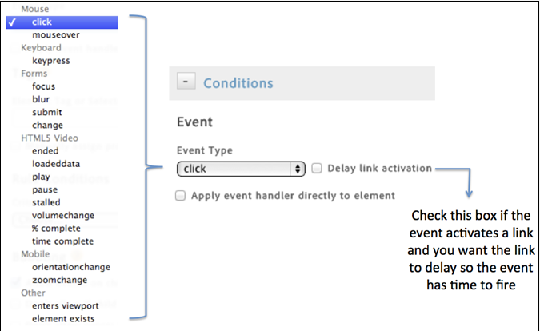

2.Enable the following options as necessary

| **Element** | **Description** |
| --- | --- |
| Delay Link Activation | Enable if the event activates a link and you want the link to delay until the event has time to fire. |
| Apply event handler directly to element | Applies the event handler to the specific element that is targeted. This setting is tied to the bubbling and layering concept in a browser. |

3.Indicate the name of the tag you want to track, and additional properties the tag has that you want to match.

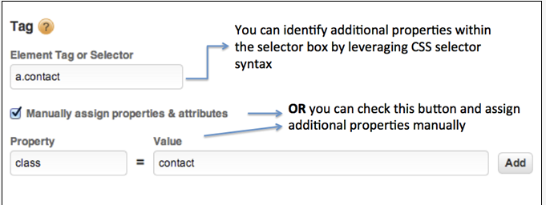

4.Select and set up any additional criteria or condition types you wish to bind to the rule.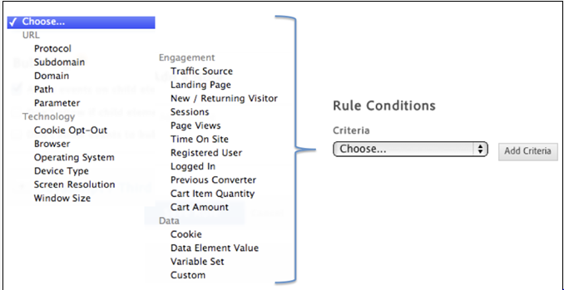

5. Indicate your preference regarding event bubbling.

Event bubbling is one way of event propagation in HTML DOM.

| **If you...** | **Check this option** |
| --- | --- |
| **Want related interactions on child elements of the rule selector you identified to fire the rule.** | Allow events on child elements to bubble. |
| **Want to prevent bubbling when the child element already triggers its own event.** | Do not allow if child element already triggers event. |
| **Don't want the events of the rule selector you identified to go beyond the element itself in the event hierarchy.** | Do not allow events to bubble upwards to parents. |

# Create Conditions for Page-Load Rules

Create rules that determine on what pages a rule is triggered.

1.Specify where on the page you want the rule to trigger.

The timing of where the rule fires on the page becomes more important when there are dependencies on page content within the rule.

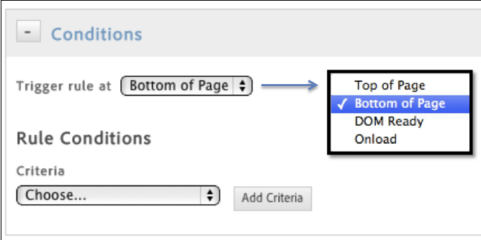

2. Specify the condition that causes the rule to fire.

For example, you can select **Path** to identify specific pages for which you want the rule to fire.

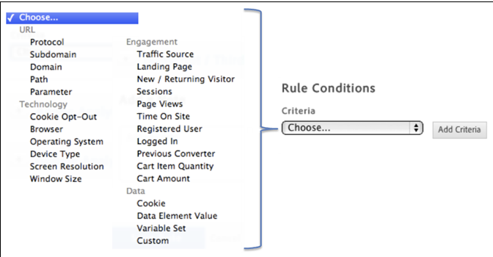

# Create Conditions for Direct-Call Rules

Create conditions for direct-call rules.

In the **Conditions** dialog, specify the string that will be passed to \_satellite.track() in your direct call, without quotes.

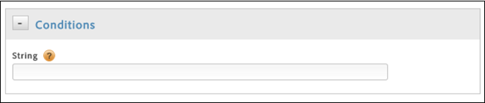

# Customize Page Code:

Use field descriptions in Dynamic Tag Management to customize page code when deploying Analytics

***Property***> **Edit Tool** > **Customize Page Code**

| **Element** | **Description** |
| --- | --- |
| Open Editor | You can insert any JavaScript call that must be triggered before the final s.t() call, which is contained in thes\_code. |
| Execute | **Before UI settings**: Interface settings take precedence over the custom code (for example, if you want to override an eVar if a setting in the interface was enabled).  **After UI settings**: Custom code takes precedence over interface settings. |

# Set Up Actions for the Condition to Trigger

Set up actions that you want the condition to trigger.

After setting up the condition, you must set up the actions that you want the condition to trigger. These actions can include Analytics events, third-party tags, and custom scripts. This example describes how to set up scripts or third-party tags.

**To set up actions for the condition to trigger**

1.Click **JavaScript / Third Party Tags** to add a new script to your rule.

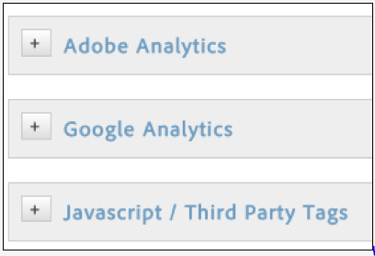

1. Click **Add New Script**.

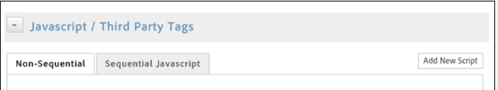

3. Name the script.

4.Show you want the script to trigger, and paste the desired content into the text area.

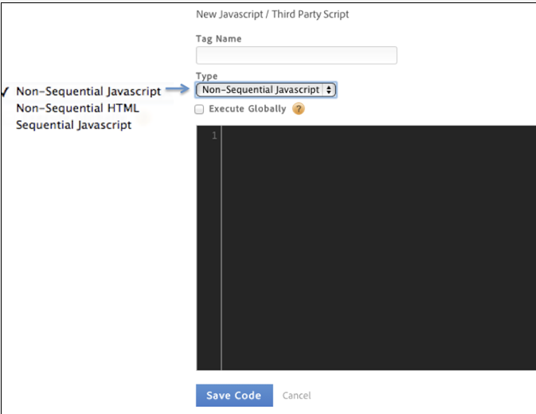

1. Click **Save Code**, and the script will be added to the queue for the rule.

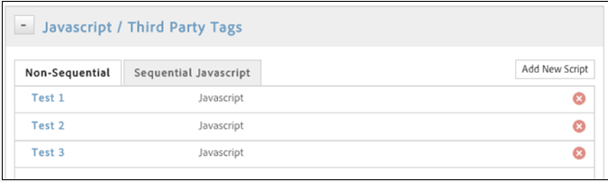

# Test Unpublished Rules for Akamai Hosting

Test unpublished rules from your console if you use Akamai hosting.

The following steps show how to test without using the Switcher plugin:

1. Access your web console on your site and type localStorage.setItem('sdsat\_stagingLibrary', true).
2. Press **Enter**.
3. Type \_satellite.setDebug(true), then press **Enter**.
4. Refresh the page.

This action loads your staging library and sets the debugger, so that you can see details of all available (published / unpublished) rules firing on the page.

1. When finished, run localStorage.setItem('sdsat\_stagingLibrary', false), then press **Enter**.

# Test Rules for Library Download or FTP:

# If you use library download or FTP delivery, or you do not have a testing environment, you can use a Rewrite tool such as Charles to test unpublished rules. This need varies based on your specific implementation.

# Custom Traffic Variable (s.prop):-

Custom traffic variables, also called props (s.prop) or property variables, are counters that count the number of times each value is sent into Analytics.

Props also let you correlate custom data with specific traffic-related events. These variables are embedded in the Analytics code on each page of your website. Through s.prop variables, Analytics lets you create custom reports, unique to your organization, industry, and business objectives.

# Note: Analytics supports up to 75 s.prop variables

You can enable and name these variables in Admin Tools under **Analytics** > **Admin** > **Report Suites** > **Edit Settings** > **Traffic** > **Traffic Variables**.

# Comparing Props and eVars

There are several types of variables available in the Experience Cloud. The two most popular types, Props and eVars, allow your organization to report on custom dimensions to your site that standard out-of-the-box reports do not offer.

**Props vs eVars**

The following are the main differences between props and eVars:

* **Naming convention**: Props are considered traffic variables, meaning they are used to report on popularity of various dimensions of your site. eVars are considered conversion variables. They are used to determine which dimensions of your site contribute the most to success events.
* **Persistence**: Props do not persist beyond the image request they were fired on. They cannot be associated with other variables that are not in the same image request. eVars, however, are persistent. A back-end variable is used to preserve the value originally fired so it can associate itself with success events later on.
* **Success events**: Success events, also known as conversion events, are metrics that measure the number of times a visitor reaches a goal. This event can be anything from purchasing something on your site, to subscribing to a newsletter. eVars are designed to report on conversion events, to show you which values are most successful in influencing visitors to reach your goals. Traffic variables do not have this same functionality. However, you can view participation metrics if you configure your report suite correctly.
* **Pathing**: Props can use pathing, which allows your organization to see a given path a user took within the context of the variable being viewed. An Adobe representative can enable pathing, if requested. eVars cannot use pathing.
* **Potentially available metrics**: The metrics available between props and eVars vary widely based on the variable's settings and data platform/version. The following list illustrates what can be enabled, not what is enabled by default. If you want a specific metric in reporting but do not see it, have one of your organization's supported users contact Customer Care.

| **Metric** | **Props**  **(Traffic Variables)** | **eVars**  **(Conversion Variables)** |
| --- | --- | --- |
| Average Page Depth | Y | N |
| Average Time Spent | Y | N |
| Bounce Rate | Y | Y |
| Bounces | Y | Y |
| Calculated Metrics | Y | Y |
| Custom Conversion Events | N | Y |
| Entries | Y | Y |
| Exits | Y | Y |
| Instances | Y | Y |
| Page Views | Y | Y |
| Participation Metrics | Y | Y |
| Purchase Metrics | N | Y |
| Reloads | Y | N |
| Shopping Cart Metrics | N | Y |
| Single Access | Y | N |
| Total Time Spent | Y | Y |
| Unique Visitors | Y | Y |
| Visits | Y | Y |

* **Breakdowns**: Props use correlations, which display page views for other traffic variables fired in the same image request. eVars use subrelations, which provide a breakdown on other conversion variables in relation to success events.

# Variables and Values

Ensure that the variables that are populated from server scripting or code cannot output any quotation marks that interfere with the values

For instance:

Ensure that the events variable is populated with an appropriate value (prodView, purchase, scAdd, scRemove, scOpen, or event1-event5) whenever products is populated. Ensure that the case of all Analytics variables and functions are maintained, as shown below.

1. s.pageName
2. s.server
3. s.channel
4. s.pageType
5. s.prop1 – s.prop20
6. s.campaign
7. s.state
8. s.zip
9. s.events
10. s.products
11. s.purchaseID
12. s.eVar1 – s.eVar20
13. var s\_code=s.t();if(s\_code)document.write(s\_code)*//-->*

Validate that links are reported in the Custom Links report. Ensure that the correct parameters are passed to the tl function. For more information on custom links, see [The s.tl() Function - Link Tracking](https://marketing.adobe.com/resources/help/en_US/sc/implement/function_tl.html#concept_EA13689CB8EE4F308FC89A1293046D5E).

# Testing and Validation Process

# Use validation and testing to ensure data reporting accuracy.

Validation and testing should always be done on the development report suite.

* [**Identifying the s\_account Variable in the DigitalPulse Debugger**](https://marketing.adobe.com/resources/help/en_US/sc/implement/impl_testing_account.html)  
  When you run the DigitalPulse Debugger, you may want to look for the *s\_account* variable.

# Identifying the s\_account Variable in the DigitalPulse Debugger

# D:\Users\ppichuka\Desktop\s_account.PNG

* [**JavaScript JS File**](https://marketing.adobe.com/resources/help/en_US/sc/implement/impl_js_file.html)  
  Verify that the .JS file is correctly referenced from the page. The path can be specified either relative to the current document, or an absolute path name can be used.
* <script language="JavaScript"
* src="//www.sampleco.com/javascript/includes/s\_code.js"></script>
* */\*\*\*\*\*\*\*\*\*\*\*\*\*\*\*\*\*\*\*\*\*\*\*\*\*\* CONFIG SECTION \*\*\*\*\*\*\*\*\*\*\*\*\*\*\*\*\*\*\*\*\*\*\*\*\*\*/*
* */\* You may add or alter any code config here. \*/*
* */\* Link Tracking Config \*/*
* s.trackDownloadLinks=false */\* true for download tracking \*/*
* s.trackExternalLinks=false */\* true for exit link tracking \*/*
* s.trackInlineStats=false */\* true for ClickMap support \*/*
* s.linkDownloadFileTypes="exe,zip,wav,mp3,mov,mpg,avi,doc,pdf,xls"
* s.linkInternalFilters="javascript:"
* s.linkLeaveQueryString=false
* s.linkTrackVars="None"
* s.linkTrackEvents="None"
* [**Code Modifications**](https://marketing.adobe.com/resources/help/en_US/sc/implement/impl_code_updates.html)  
  Testing any modifications to the .JS file or HTML code is the responsibility of the customer. It should be completed prior to publishing the modifications to production websites.

1. <html><head></head><body>
2. ...paste code here to debug...
3. </body></html>

* [**Variables and Values**](https://marketing.adobe.com/resources/help/en_US/sc/implement/impl_var_values.html)  
  Ensure that the variables that are populated from server scripting or code cannot output any quotation marks that interfere with the values.
* s.pageName="Article: "**Article** **Name**""
* s.pageName='Company's **Information**'
* s.pageName
* s.server
* s.channel
* s.pageType
* s.prop1 – s.prop20
* s.campaign
* s.state
* s.zip
* s.events
* s.products
* s.purchaseID
* s.eVar1 – s.eVar20
* var s\_code=s.t();if(s\_code)document.write(s\_code)*//-->*
* [**Custom Variables**](https://marketing.adobe.com/resources/help/en_US/sc/implement/impl_custom_vars.html)  
  List of custom variables used in Analytics.

| **Variable** | **Description** |
| --- | --- |
| Traffic Variables | Check the value of prop1 - 75. Here is a checklist of items to check.   * Is the correct case used? "ValueA" is a different record than "valueA." You can use all lowercase since a small subset of browsers convert all variables to lower case. * Are the values less than 100 characters in length? If not, some clipping of the values can occur. * Are all the values in a single property variable related, or do some values look out of place? |
| Conversion Variables | Econversion variables include eVar 1 - 75. Here is a list of issues to check for the following.   * Is the correct case used? "ValueA" is a different record than "valueA." You can use all lowercase since a small subset of browsers convert all variables to lower case. * Are the values less than 255 characters in length? If not, some clipping of the values can occur. * Are all the values in a single eVar related, or do some values look out of place? |
| Custom Events | Events include both standard values (prodView, scOpen, scAdd, scCheckout, purchase), as well as custom events from event1 to event100. All events are sent in the events variable. Multiple events on the same page should be comma-delimited (no white space).   * For all the standard conversion events, products should also be populated with the applicable products. For all events except purchase, the qty and price elements are optional. * The purchase event, must be set only once in a session after the purchase has been completed and confirmed. |

* [**Implementation Acceptance**](https://marketing.adobe.com/resources/help/en_US/sc/implement/impl_acceptance.html)  
  Implementation process steps.

The following steps outline the implementation process.

1. The Adobe Consultant gathers report requirements and creates a data collection plan based on those requirements.

The data collection plan includes variable definitions, required VISTA rules and custom JavaScript, data correlation, and all settings for each report suite. The client completes the Implementation Questionnaire.

1. Technical resources on the client-side implement the code, site-specific JavaScript, and server-side variables.
2. The Adobe Consultant addresses technical issues during the implementation and assists in devising solutions as required.
3. Technical resources on the client-side unit test the implementation.

Testers log in to Analytics and verifying all variables (*page name*, *channel*, *server*, *events*, *campaign*, econversion variables, custom traffic variables, *products*, and all other variables).

1. The client notifies Adobe that the implementation is complete.

The client provides a validation sample (data sample) to the Adobe Consultant to validate data accuracy. (VISTA-generated report suites are validated by comparing appropriate metrics. A client-Adobe agreement of the metrics to be validated for such report suites shall be made in advance, at the time of the VISTA rule creation.)

1. The client faxes (or signs online) an Implementation Acceptance and Agreement for the appropriate site(s).
2. After the acceptance has been received, the Adobe Consultant enables the Adobe Best Practices - Implementation Verification certification within the interface.
3. Optionally, the client can contract with Adobe for monitoring services for key pages of the implemented site (generally, these are the primary templates, home page, and critical entry pages).

This monitoring software is described in a separate document, but tracks pages by loading and executing the page, then comparing the image request to a baseline stored in a database. If any differences are detected, the software notifies specified Adobe (AM/IE) and client personnel via email.

* [**Data Accuracy Validation**](https://marketing.adobe.com/resources/help/en_US/sc/implement/impl_data_accuracy.html)  
  Data accuracy validation is a process of comparing report data with known and verifiable data points.

Data accuracy validation is a process of comparing report data with known and verifiable data points.

The validation process should be completed by Adobe personnel, preferably by the Adobe Consultant (the person most familiar with the technical implementation details).

The preferred data points for this validation, in order of preference, are listed as follows:

* (Econversion sites) Comparison of econversion orders for a single day.
* Comparison of known success events, especially logged data where IP address and other browser information generally stored in web server logs can be compared to the data collected.
* Comparison of page views.